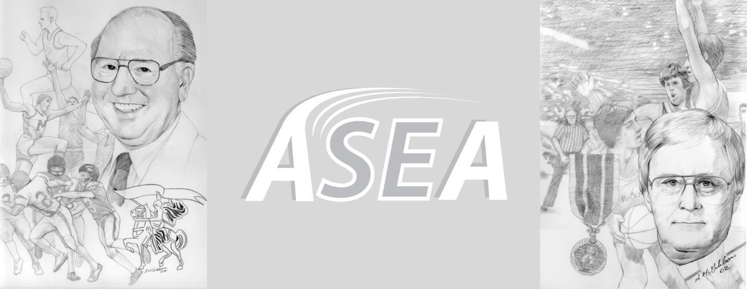
\\\
Skiffington / Grant Challenge

Date: Saturday, May 21st, 2022
Time: 9:30am - 5:30pm
Classification: Outdoor Track and Field Meet
Location: Croix-Bleue Medavie Stadium, Moncton, NB
Primary Contact: Peter Stuart (stuart@nbnet.nb.ca)
Organized by: Athlétisme Sud-Est / South-East Athletics (ASEA)

Ed Skiffington (Moncton High School) and Don Grant (Harrison Trimble High School) each

Skiffington / Grant Challenge

Organized by : ASEA
Primary Contact : Peter Stuart , stuart@nbnet.nb.ca
Co-Host : Riverview High School
Date : Saturday May 24
Time: 8:30am - 5:30 pm
Location : Medavie Blue Cross Stadium
Classification: Outdoor Track and Field Meet
.
Events : 80m, 100m, 150m, 200m,300m, 400m, 800m, 1200m, 1500m, 1500ms/c, 2000ms/c, 3000ms/c, 80mh, 100mh, 110mh, 200mh, 300mh, 400mh, Long Jump, Triple Jump, High Jump, Shot Put, Discus, Javelin, Hammer

Registration: First event $25.00. Second event $15.00. All other events are $10.00 each. All athletes should be registered by Wednesday May 21 at 11:59pm. There will be no onsite registration.

Organized by Athlétisme Sud-Est / SouthEast Athletics (ASEA).
Sanctioned by Athletics New Brunswick ( ANB ) and the New Brunswick Interscholastic Association ( NBIAA).

All events will be divided into NBIAA sections & non-NBIAA sections.

Défi Skiffington / Grant

Organise par : ASEA
Contact primaire: Peter Stuart , stuart@nbnet.nb.ca
Date: Samedi le 24 mai
Quand: 8:30am - 5:30 pm
Location: Stade Medavie Croix Bleu
Classification: Outdoor Track and Field Meet
.
Evenements: 80m, 100m, 150m, 200m, 400m, 800m, 1200m, 1500m, 1500ms/c, 2000ms/c,3000ms/c , 80mh, 100mh, 110mh, 200mh, 300mh, 400mh, LJ, TJ, HJ, SP, Dis, Jav, Ham

Inscriptions: La premiere evement est 25.00$. Deuxieme evenements est 15.00$. Les evenements additionale est 10.00$ Tous les athletes doivent etre inscris par le 21 mai at 23h59. Aucune athlete voit etre accepter apres.

Chaque participant doit accepter de ce conformer a tout les reglements de ANB et AC.

Organisé en conjonction avec athlétisme nouveau brunswick et le ASINB.
Les évènements auront être séparé par organe directeur (ASINB ou ANB).

Tentative Track Schedule (Horaire tentative du piste)
( female before male, younger age groups to older )
( groups might be combined depending on entries)
8:30am
2000m - U14/U16 Female & Male
3000m - U18/ U20. Senior/ Masters
200mh - U14/U16 Female & Male
300m hurdles - U14/U16 Female
400m hurdles - U18/U20/ senior Female
300m hurdles - U14/ U16 Male
400m Hurdles - U18/U20/ Senior Male
80m heats - U12/U14 female
80m heats - U12/U14 Male
100m heats - U16/U18/U20/open/ Masters female
100m heats - U16/U18/U20/open/ Masters male
800m - U16 and older female
800m - U16 and older male
80m finals - U14 female U14 Male
100m finals - U16/U18/U20/open/ Masters female
100m finals - U16/U18/U20/open/ Masters male
Featured Events
1000ms/c- U14 male & Female
1500ms/c - U16 Female & Male
2000ms/c - U18 Female
2000ms/c - U18 Male
3000ms/c - U20 and older Female
3000ms/c - U20 and older Male

Break ( approx 1:00-1:30pm )

150m timed final - U14
200m timed final - U16/U18/U20/open/ Masters female
200m timed final - U16/U18/U20/open/ Masters male
80m hurdles finals - U14/ U16 Female; U16 Female, Masters,
100m hurdles finals - U16 male, U18/U20/Open female, Masters
110m hurdles finals - U18/U20/Open male, Masters
1200m - U14/ U16 female
1200m - U14/ U16 male
1500m - U18 and older female
1500m - U18 and older male
300m timed final - U16 female
300m timed final - U16 male
400m timed final - U18 and older female
400m timed final - U18 and older male

Tentative Field Schedule (Horaire tentative)
9:00am - Female Shot Put
9:00am - Male Discus
9:30am -Male Long Jump
11:00am -Female triple ( after male long jump )
10:15am - Male discus
11:00am - Female Shot put

After Break ( should be at approx 12:00 )
12:00 - All High Jump
12:00- Female Javelin
12:00 - Female long jump
1:30pm - Male Triple jump ( after female long jump)
1:30pm - Male Javelin
3:00pm - Female & Male Hammer Featured Event



